Details required for Provident Fund for Employees

Please enter the details as mentioned in Aadhar and PAN of the employee
Existing UAN (if any):
Name: | Parvendra Rajput
Fathers Name: | Gajendra Singh Rajput
Date of Birth: | 18 September 2002
PAN: | FFJPR6946M
Aadhar Number: | 645655325517
E-mail: | prvenrjputs@gmail.com
Phone: | 8085416865

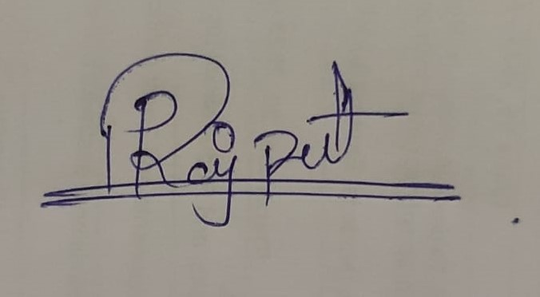
Signature of the Employee:
Name of the Employee: Parvendra Rajput

Please provide the following documents along with a scanned signed copy of this form:
- Aadhar Card of Employee
- PAN Card of Employee
- Soft Copy of this form in Word Format

